SIMATS ENGINEERING
ASSESSMENT TOOL 1 : Concept Mapping

COURSE NAME: | Cloud Computing and Big Data Analytics | COURSE CODE: | CSA15

COURSE OUTCOME COVERED
CO1: Apply cloud computing technologies including hardware-software evolution, virtualization, web services, and service models to develop cloud-based solutions. (BL2)

Dave's Taxonomy: Imitation (Level 1)  Question Count: 4 | Total Marks: 50

Code of Conduct
I Keerthana.G(192521446) certify that this submission is my original work and that I have adhered to the guidelines specified for this assessment.
I understand that any violation of academic integrity rules will result in disciplinary action.
Signature of the student: __________________________________________
Assessment Tasks
Concept Mapping Tasks
Create concept maps for the following tasks. Each map must show key nodes, link labels, and a logical hierarchy.
- Concept Map 1: Cloud Computing Fundamentals. Include definition, characteristics, benefits, and limitations.
- Concept Map 2: Evolution of Cloud Computing. Connect hardware evolution, internet software evolution, distributed systems, and service delivery.
- Concept Map 3: Service Models. Map IaaS, PaaS, SaaS, and XaaS with provider responsibilities and user responsibilities.
- Concept Map 4: Virtualization and Web Services as Enablers of Cloud. Show how these two concepts support cloud deployment and scalability.
Expected concept nodes:
- Elasticity, scalability, resource pooling, on-demand access, measured service
- Virtual machine, hypervisor, abstraction, API, SOAP, REST, provider, consumer
- Infrastructure layer, platform layer, application layer, shared responsibility

Concept Mapping Rubric

Criteria | Weightage | Level 4 - Exemplary | Level 3 - Proficient | Level 2 - Developing | Level 1 - Beginning
Concept Identification | 25% | All major concepts are accurately identified | Most concepts are identified correctly | Limited concepts are identified | Essential concepts are missing
Relationship Mapping | 25% | Links between concepts are accurate and meaningful | Most links are correct | Some links are weak or unclear | Relationships are mostly incorrect
Hierarchy and Organization | 20% | Excellent structure with clear hierarchy | Mostly organized with minor issues | Basic structure with weak hierarchy | No logical organization
Technical Relevance | 20% | Map strongly reflects cloud course content | Mostly aligned to topic | Partially aligned to topic | Weak alignment to topic
Visual Clarity | 10% | Neat, readable, and easy to interpret | Generally readable | Somewhat cluttered | Poorly presented

Total Marks:

Permitted Tools :
draw.io / diagrams.net, Lucidchart, MindMeister, Miro, Canva, PowerPoint, Google Drawings, or equivalent diagramming tool

Procedure for Preparing the Digital Concept Map
- Use the following procedure to prepare the diagram and upload evidence.
- Students who already know another diagramming tool may use it, but the exported evidence and source file must still be submitted.
- Open https://app.diagrams.net/ or the desktop version of draw.io / diagrams.net.
- Choose Device, Google Drive, or OneDrive as the save location according to availability.
- Create a blank diagram and name the file as CSA15_CO1_AT1_RegisterNumber_Concept_Map.drawio.
- Place the concept map title at the center or as a clearly visible anchor node.
- Add major cloud nodes: cloud definition, cloud evolution, cloud architecture, service models, deployment models, virtualization, web services, SOAP, REST, APIs, elasticity, scalability, resource pooling, measured service, and emerging paradigms.
- Connect nodes with labeled arrows such as uses, depends on, enables, scales through, communicates through, belongs to, supports, provides, consumes, or controls.
- Use colors meaningfully: one color for service models, one for cloud characteristics, one for API/web-service concepts, and one for concept map title-specific elements.
- Export the final diagram as PNG or PDF. Keep the editable .drawio source file also.
- Paste the exported diagram image or screenshot in this DOCX under Task 1.
- Upload the DOCX, exported PNG/PDF, and .drawio file to Google Classroom.

Task 1: Concept Map
Create a concept map in draw.io, Lucidchart, Miro, Figma, or any suitable diagramming tool. The map must connect cloud ecosystem, cloud actors, service models, deployment models, virtualization, web services, REST/SOAP APIs, scalability, elasticity, and the student's Project.

Task 2A: Service Model Responsibility Matrix
Prepare a technical matrix that compares SaaS, PaaS, IaaS, FaaS/serverless, database-as-a-service, storage-as-a-service, identity-as-a-service, and monitoring/logging services. For each selected service category, explain what is managed by the cloud provider, what is managed by the student application team, and why that split fits the Project.

Task 2B: Cloud Service Decision Matrix
Map Project modules to cloud services. Include authentication, frontend hosting, backend/API layer, database, object storage, analytics/logging, notification, AI/Python module, security, CI/CD, backup, and monitoring. Students should justify the most relevant service choices instead of forcing every possible cloud service into the design.

Task 3: API Flow, Elasticity, and Scalability Design
Draw a professional cloud-flow diagram for the Project modules. The diagram must show user app or web app, API gateway/backend service, authentication, compute layer, database, object storage, analytics/logging, monitoring, security boundaries, and scaling points. Students may replicate the given visual pattern, but all components and labels must be customized to their own architecture.

Task 4: Technical Justification
Write a concise justification explaining how the diagram and matrices prove CO1. The justification must discuss service model selection, API role, elasticity, scalability, virtualization or managed compute choice, and cloud responsibility boundaries.

1. Evaluate the effectiveness of your concept map in representing cloud computing principles. Which design decisions most strongly support your solution, and why?
2. Analyze how scalability, elasticity, and resource management influence the architecture shown in your concept map. What challenges could arise if these capabilities were absent?
3. Justify the selection of the APIs, web services, or cloud services included in your concept map. How do they contribute to the overall functionality and efficiency of the system?
4. Critically examine the relationships between the components in your concept map. How do these interactions improve reliability, performance, or user experience?
5. Reflect on the process of developing your concept map. How has creating and analyzing the map changed your understanding of cloud computing architecture, and what improvements would you make if you were redesigning it?

Expected Digital Evidence
- Editable diagram source file and exported PNG/PDF for the concept map.
- Completed service model responsibility matrix and cloud service decision matrix.
- Architecture/API flow diagram exported as PNG/PDF.
- README file containing title, tools used, repository structure, and a short CO1 reflection.
GitHub and Google Classroom Submission
- Create a repository using a clear name: CSA15_CO1_AT<Number>_<RegisterNumber>.
- Upload editable source files, exported PDF/PNG evidence, screenshots, and a short README explaining the work.
- Keep filenames professional and include the register number where appropriate.
- Submit only the GitHub repository link in Google Classroom before the deadline.
- Ensure the repository is accessible to the faculty evaluator during assessment.
Implementation Note
Faculty may evaluate the submitted evidence digitally using repository inspection, diagram quality, oral explanation, and CO-aligned rubric scoring. The focus is on technical understanding, cloud design reasoning, and hands-on evidence rather than routine written work.

Task 1: Concept Map
Create a concept map in draw.io, Lucidchart, Miro, Figma, or any suitable diagramming tool. The map must connect cloud ecosystem, cloud actors, service models, deployment models, virtualization, web services, REST/SOAP APIs, scalability, elasticity, and the student's Project.

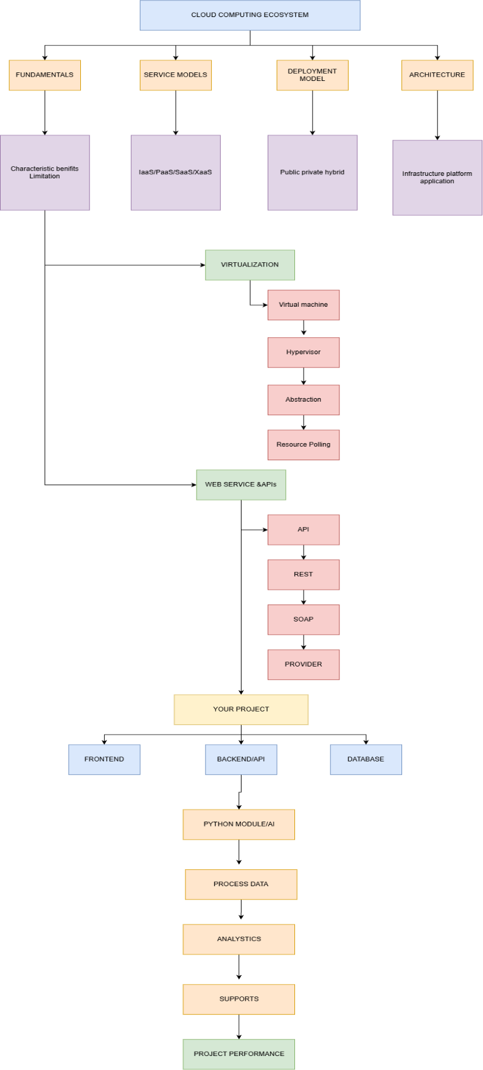

Task 2A: Service Model Responsibility Matrix
Prepare a technical matrix that compares SaaS, PaaS, IaaS, FaaS/serverless, database-as-a-service, storage-as-a-service, identity-as-a-service, and monitoring/logging services. For each selected service category, explain what is managed by the cloud provider, what is managed by the student application team, and why that split fits the Project.

Service Category | Cloud Provider Manages | Student Application Team Manages | Why This Split Fits the Project
SaaS | Application infrastructure, software updates, runtime environment, availability and underlying cloud resources. | User configuration, OptiCompile project data, application settings and service usage. | SaaS reduces infrastructure management when ready-to-use cloud software is required for development and collaboration.
PaaS | Servers, operating system, runtime environment, networking, infrastructure maintenance and platform scaling. | OptiCompile source code, REST APIs, application configuration, application data and deployment settings. | PaaS is suitable for hosting the OptiCompile frontend and backend while reducing server administration.
IaaS | Physical servers, data-center facilities, networking hardware, storage hardware and virtualization infrastructure. | Operating system, runtime, compiler tools, application code, APIs, configuration and application-level security. | IaaS is useful when OptiCompile requires greater control over the compiler execution environment
FaaS / Serverless | Servers, operating system, runtime infrastructure, resource provisioning and automatic scaling. | Functions, compiler-processing logic, triggers, input/output handling and application code. | Serverless execution can support short and event-driven compiler analysis or processing tasks without managing servers.
Database-as-a-Service | Database infrastructure, database software, patching, backups, replication, availability and maintenance. | Database schema, tables, queries, project records, application data and access policies. | A managed database can store user information, project metadata, compilation results and application records.
Storage-as-a-Service | Storage infrastructure, durability, replication, availability and underlying storage maintenance. | Source files, generated files, compilation outputs, reports, folders and access policies. | Cloud storage is suitable for storing uploaded source code and generated compiler artifacts without managing physical storage.
Identity-as-a-Service | Identity infrastructure, authentication mechanisms, credential security and identity service availability. | User roles, permissions, application access rules and integration of authentication with OptiCompile. | Identity services provide secure authentication and controlled access to OptiCompile resources
Monitoring / Logging | Monitoring infrastructure, log collection platform, log storage infrastructure and service availability. | Application logs, compiler execution logs, performance metrics, alerts and analysis of application behaviour. | Monitoring and logging help identify API failures, compiler errors, performance problems and service availability issues.

Task 2B: Cloud Service Decision Matrix
Map Project modules to cloud services. Include authentication, frontend hosting, backend/API layer, database, object storage, analytics/logging, notification, AI/Python module, security, CI/CD, backup, and monitoring. Students should justify the most relevant service choices instead of forcing every possible cloud service into the design.

Project Module | Selected Cloud Service | Justification
Authentication | Identity-as-a-Service | Provides managed authentication, secure identity management and role-based access for OptiCompile users.
Frontend Hosting | PaaS / Static Web Hosting | Hosts the OptiCompile web interface while reducing the need to manage servers and operating systems.
Backend / API Layer | PaaS | Provides a managed environment for deploying OptiCompile backend services and REST APIs.
Database | Database-as-a-Service | Provides managed database infrastructure for user information, project metadata and compilation records.
Source Code / Output Storage | Storage-as-a-Service | Provides scalable storage for uploaded source files, generated outputs and compiler reports.
Analytics / Logging | Monitoring / Logging | Captures application activity, compiler execution information, errors and performance metrics.
Security | Identity-as-a-Service + Cloud Security | Supports authentication, authorization and controlled access to OptiCompile resources
CI/CD | Cloud CI/CD Service | . Automates code building, testing and deployment of the OptiCompile application.
AI / Python Module | FaaS / Serverless or PaaS | Supports Python-based code analysis and processing while allowing compute resources to scale according to workload.
Backup | Database-as-a-Service + Storage-as-a-Service | Protects application records, source files and generated compiler artifacts against data loss
Monitoring | Monitoring / Logging | Tracks application health, API performance, errors and resource usage.

Task 3: API Flow, Elasticity, and Scalability Design
Draw a professional cloud-flow diagram for the Project modules. The diagram must show user app or web app, API gateway/backend service, authentication, compute layer, database, object storage, analytics/logging, monitoring, security boundaries, and scaling points. Students may replicate the given visual pattern, but all components and labels must be customized to their own architecture.

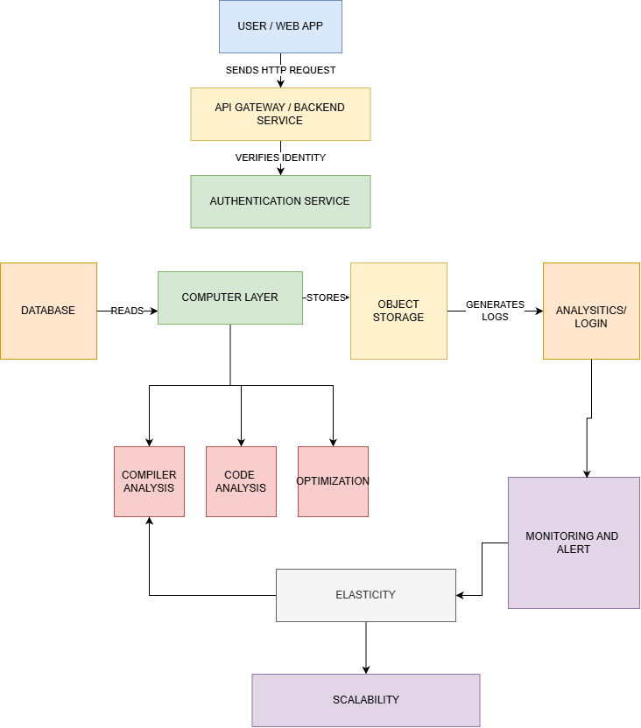

Task 4: Technical Justification
Write a concise justification explaining how the diagram and matrices prove CO1. The justification must discuss service model selection, API role, elasticity, scalability, virtualization or managed compute choice, and cloud responsibility boundaries.

1. Evaluate the effectiveness of your concept map in representing cloud computing principles. Which design decisions most strongly support your solution, and why?

- The concept map clearly represents the major cloud computing principles and their relationships.
- It shows how users, APIs, cloud services, compute resources, storage, and databases interact.
- The selection of cloud service models helps explain how different resources are provided to users.
- APIs and web services show how applications communicate with cloud resources.
- Scalability and elasticity demonstrate how resources can increase or decrease based on workload.
- The use of virtualized or managed compute resources shows efficient utilization of cloud infrastructure.
- The map also represents resource management, which helps in allocating resources according to demand.
- Clear connections between components make the overall architecture easier to understand.
- The design supports the concept of on-demand resource usage and flexible cloud deployment.
- Overall, the concept map provides a structured view of how different cloud components work together.
2. Analyze how scalability, elasticity, and resource management influence the architecture.

- Scalability allows the system to handle increasing numbers of users and workloads.
- Elasticity allows cloud resources to automatically increase or decrease according to demand.
- Resource management ensures that CPU, memory, storage, and network resources are used efficiently.
- These capabilities help maintain consistent application performance during high traffic.
- During low demand, unnecessary resources can be reduced to avoid wastage and cost.
- Auto-scaling can distribute workloads across multiple resources.
- Load balancing can prevent a single server from becoming overloaded.
- Without scalability, the system may become slow when the number of users increases.
- Without elasticity, resources may remain underutilized during low-demand periods.
- Without proper resource management, the system may experience resource wastage, higher cost, poor performance, and service failures.
3. Justify the selection of APIs, web services, or cloud services.
- APIs provide communication between the application and cloud services.
- APIs allow different components to exchange data without directly depending on their internal implementation.
- Web services help connect application functions with external or cloud-based resources.
- Cloud services provide required computing, storage, database, and networking capabilities.
- APIs make the system more modular and flexible.
- They allow services to be integrated and reused easily.
- Cloud-based services reduce the need to maintain physical infrastructure.
- Managed cloud services can improve availability, reliability, and efficiency.
- API-based communication supports faster data exchange between application components.
- Therefore, the selected APIs and cloud services contribute to better functionality, scalability, maintainability, and performance.

- Critically examine the relationships between the components

- The user/application layer communicates with cloud resources through APIs.
- APIs connect the application with backend services and databases.
- Compute resources process user requests and application workloads.
- Storage services maintain application data and files.
- Databases provide structured and reliable data management.
- Load balancing distributes requests among available resources.
- Scalability and elasticity work with compute resources to handle changing workloads.
- Resource management ensures that available resources are allocated efficiently.
- These interactions reduce the possibility of a single resource becoming overloaded.
- Redundancy and distributed resources can improve reliability and availability.
- Efficient communication between components improves system performance.
- Faster and reliable responses provide a better user experience.

- Reflect on the process of developing your concept map.

- Developing the concept map helped me understand how different cloud computing components are interconnected.
- I learned that cloud computing is not only about storing data online but also involves compute, networking, APIs, security, storage, scalability, and resource management.
- Creating the map helped me understand the relationship between service models and cloud resources.
- It improved my understanding of how APIs connect applications with cloud services.
- I also understood the importance of scalability and elasticity in handling changing workloads.
- The concept map made the cloud architecture easier to visualize compared with studying each concept separately.
- It helped me identify the responsibilities of different cloud components.
- If redesigning the map, I would improve the grouping and labeling of components.
- I would clearly separate application, service, infrastructure, and user layers.
- I would also add more details about security, monitoring, fault tolerance, and cost management.
- Overall, creating the concept map improved my understanding of how cloud services work together to provide a reliable and scalable system.

